1 | Principio del formulario
  A network administrator is evaluating RIP versus EIGRP for a new network. The network will be sensitive to congestion and must respond quickly to topology changes. What are two good reasons to choose EIGRP instead of RIP in this case? (Choose two.)
   | EIGRP uses periodic updates.
   | EIGRP only updates affected neighbors.
   | EIGRP uses broadcast updates.
   | EIGRP updates are partial.
   | *EIGRP uses the efficient Bellman-Ford algorithm.
2 | Principio del formulario
  Which of the following statements are correct about RIP?
   | uses a broadcast to update all other routers in the network every 60 seconds
   | uses a multicast address to update other routers every 90 seconds
   | will send out an update if there is a failure of a link
   | *updates only contain information about routes that have changed since last update

3 | Principio del formulario
  Which of the following can exist in a distance vector network that has not converged? (Choose three.)
   | routing loops
   | inconsistent traffic forwarding
   | no traffic forwarding until system converges
   | inconsistent routing table entries
   | routing table updates sent to wrong destinations
4 | Principio del formulario
  What does a router running RIP do first with a new route that is received from an advertisement?
  places it immediately in the routing table
  adjusts the metric for the new route to show the added distance for the route
  advertises this route out all other interfaces except the one that it came in on
  *sends a ping packet to verify that the path is a feasible route

5 | Principio del formulario
  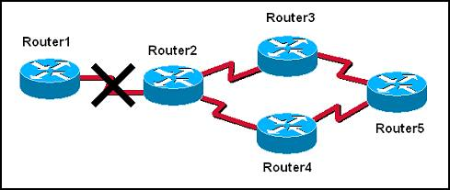
  The graphic shows a network that is configured to use RIP routing protocol. Router2 detects that the link to Router1 has gone down. It then advertises the network for this link with a hop count metric of 16. Which routing loop prevention mechanism is in effect?
   | split horizon
   | error condition
   | hold-down timer
   | route poisoning
   | count to infinity
6 | Principio del formulario
  What does the RIP holddown timer do?
  ensures an invalid route has a metric of 15
  prevents a router from sending any updates after it has introduced a routing loop into the network
  ensures every new route is valid before sending an update
  instructs routers to ignore updates, for a specified time or event, about possible inaccessible routes

7 | Principio del formulario
  What is a routing loop?
   | a packet bouncing back and forth between two loopback interfaces on a router
   | a condition where a return path from a destination is different from the outbound path forming a "loop"
   | a condition where a packet is constantly transmitted within a series of routers without ever reaching its intended destination
   | the distribution of routes from one routing protocol into another
8 | Principio del formulario
  Which event will cause a triggered update?
  an update routing timer expires
  a corrupt update message is received
  a route is installed in the routing table
  *the network is converged

9 | Principio del formulario
  Which two conditions are most likely to cause a routing loop? (Choose two.)
  random jitter
  implementation of classful addressing
  inconsistent routing tables
  incorrectly configured static routes
  a network converging too quickly
10 | Principio del formulario
  Three routers running a distance-vector routing protocol lost all power, including the battery backups. When the routers reload, what will happen?
  They will share all routes saved in NVRAM prior to the power loss with their directly connected neighbors.
  They will multicast hello packets to all other routers in the network to establish neighbor adjacencies.
  They will send updates that include only directly connected routes to their directly connected neighbors.
  *They will broadcast their full routing table to all routers in the network.

11 | Principio del formulario
  Which of the following methods does split horizon use to reduce incorrect routing information?
  Routing updates are split in half to reduce the update time.
  Information learned from one source is not distributed back to that source.
  New route information must be learned from multiple sources to be accepted.
  The time between updates is split in half to speed convergence.
  New route information is suppressed until the system has converged.
12 | Principio del formulario
  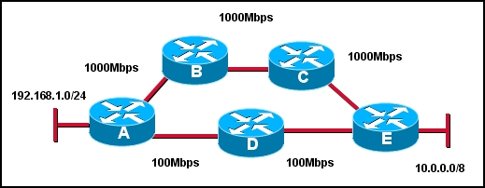
  Refer to the exhibit. What path will packets from the 192.168.1.0/24 network travel to reach the 10.0.0.0/8 network if RIP is the active routing protocol?
  The path will be router A -> router B -> router C -> router E.
  The path will be router A -> router D -> router E.
  *Router A will load balance between the router A -> router D -> router E and router A -> router B -> router C -> router E paths.
  Packets will alternate paths depending on the order they arrive at router A.

13 | Principio del formulario
  Which two statements are true regarding the function of the RIPv1 routing updates? (Choose two).
  *updates are broadcast only when there are changes to the topology
  updates are broadcast at regular intervals
  broadcast are sent to 0.0.0.0
  broadcasts are sent to 255.255.255.255
  updates contain the entire network topology
  *only changes are included in the updates
14 | Principio del formulario
  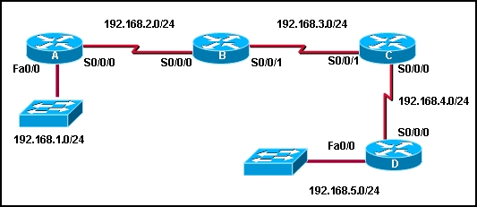
  Refer to the exhibit. If all routers are using RIP, how many rounds of updates will occur before all routers know all networks?
  1
  2
  3
  *4
  5
  6

15 | Principio del formulario
  Which statement is true regarding cisco’s RIP_JITTER variable?
  It prevents the synchronization of routing updates by buffering the updates as they leave the router interfaces.
  *It prevents the synchronization of routing updates by subtracting a random length of time ranging from 0% to 15% of the specified interval time from the next routing update interval.
  It prevents the synchronization of routing updates by causing the router to skip every other scheduled update time.
  It prevents the synchronization of routing updates by forcing the router to listen when its time for other updates on the lines before sending its update.
16 | Principio del formulario
  What metric does the RIP routing protocol consider to be infinity?
  0
  15
  16
  224
  255
17 | Principio del formulario
  What is the purpose of the TTL field in the IP header?
  used to mark routes as unreachable in updates sent to other routers
  prevents regular update messages from reinstating a route that may have gone bad
  prevents a router from advertising a network through the interface from which the update came
  *limits the time or hops that a packet can traverse through the network before it should be discarded
  defines a maximum metric value for each distance vector routing protocol by setting a maximum hop count

18 | Principio del formulario
  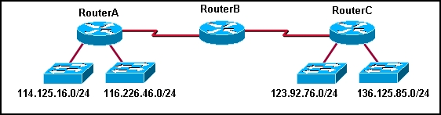
  What actions will occur after RouterA loses connectivity to network 114.125.16.0? (Choose two.)
  RouterB will include network 123.92.76.0 and 136.125.85.0 in its update to RouterA.
  During the next update interval, RouterB will send a RIP update out both ports that includes the inaccessible network.
  During the next update interval, RouterC will send an update to RouterB stating that network 114.125.16.0 is accessible in 2 hops.
  Router C will learn of the loss of connectivity to network 114.125.16.0 from RouterB.
  RouterB will include network 123.92.76.0 and 136.125.85.0 in its update to RouterC.
19 | Principio del formulario
  Which three routing protocols are distance vector routing protocols? (Choose three).
   | RIPv1
   | EIGRP
   | OSPF
   | IS-IS
   | RIPv2

20 | Principio del formulario
  Which two statements describe EIGRP? (Choose two.)
  EIGRP can be used with Cisco and non-Cisco routers.
  EIGRP sends triggered updates whenever there is a change in topology that influences the routing information.
  EIGRP has an infinite metric of 16.
  EIGRP sends a partial routing table update, which includes just routes that have been changed.
  EIGRP broadcasts its updates to all routers in the network.
21 | Principio del formulario
  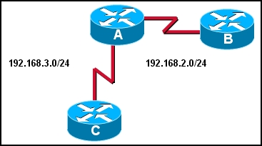
  Refer to the exhibit. The routers in this network are running RIP. Router A has not received an update from Router B in over three minutes. How will Router A respond?
  *The Holddown timer will wait to remove the route from the table for 60 seconds.
  The Invalid timer will mark the route as unusable if an update has not been received in 180 seconds.
  The Update timer will request an update for routes that were learned from Router B.
  The Hello timer will expire after 10 seconds and the route will be flushed out of the routing table.
Max Points: 44 Earned Points: 14 Percentage: 31.8%
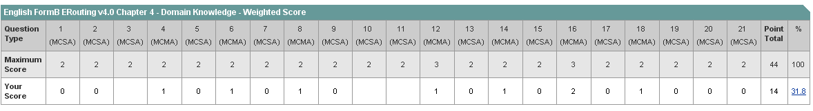
Intento 2 (las que están con amarillo)
Max Points: 44 Earned Points: 27 Percentage: 61.4%
